นายพีรณัฐ ธารทะเลทอง 550610530
Digital Image Processing (261453)
Computer Assignment 1
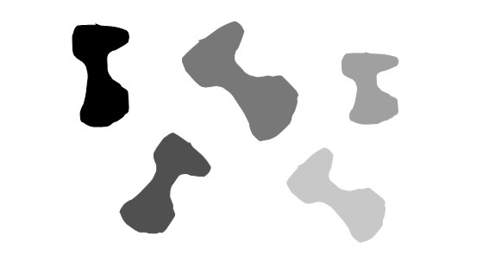
1. Histogram and Object Moment
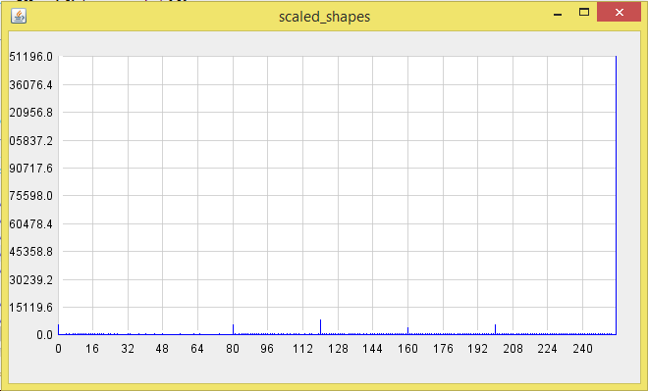
รูป input
Histogram
จาก Histogram จะเห็นว่ามีค่าที่โดดขึ้นมา 6 ค่า และค่าที่ระดับ 255 คือสีขาวที่เป็น background ดังนั้น 5 ค่าที่เหลือคือ object โดยแต่ละ object มีค่า gray level ที่ 0, 80, 120, 160, 200

ค่า Quantity จะขึ้นอยู่กับรูปร่างและขนาดของรูป Object สังเกตุจากค่า Quantity ของ Object 1, 2, 5 ที่มีค่าใกล้เคียงกัน เพราะว่ามีขนาดและรูปร่างใกล้เคียงกัน แค่หมุนรูปเฉยๆ
Object 1
Gray level : 0
Center of mass : x = 116.130408532904, y = 85.51298047896961
Central moments : U20 = 1100035.4952706748, U02 = 6345057.412758953
Quantity : 0.3015311112447032

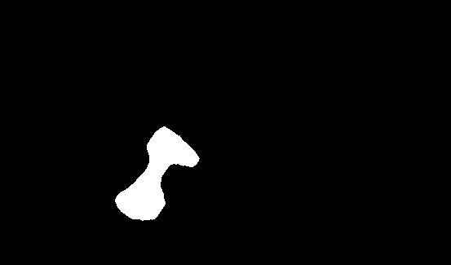
Object 2
Gray level : 80
Center of mass : x = 189.08030669895078, y = 215.0449959644875
Central moments : U20 = 2456890.0379338027, U02 = 4941000.965899928

Quantity : 0.30119331814209316
Object 3
Gray level : 120
Center of mass : x = 280.5477487050073, y = 95.14982069331917
Central moments : U20 = 8460663.084340539, U02 = 7875173.002258037
Quantity : 0.2881819480564569
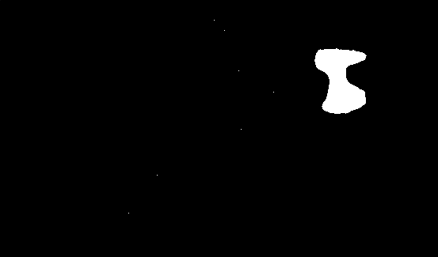
Object 4
Gray level : 160
Center of mass : x = 428.01040462427744, y = 100.97976878612717
Central moments : U20 = 975991.6254335531, U02 = 2194070.5838150145
Quantity : 0.2647985406502529
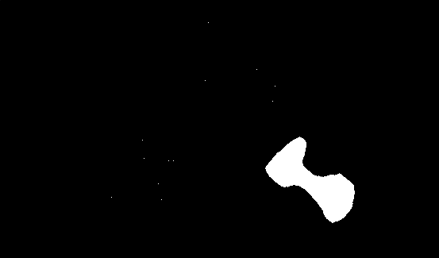
Object 5
Gray level : 200
Center of mass : x = 391.4387487386478, y = 227.5313824419778
Central moments : U20 = 4792344.160242188, U02 = 3007131.8700302355
Quantity : 0.3176713949367689
2. Point Operations
เริ่มจากหา Histogram ของรูป จากนั้นหาร Histogram แต่ละค่าด้วยพื้นที่ของรูป จะได้ Probability mass function
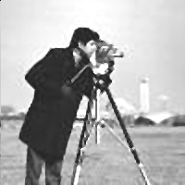
จากนั้นหา cdf โดยการบวกค่าก่อนหน้าของ Probability mass function มาเรื่อยๆ จากนั้นคูณ cdf แต่ละค่าด้วยค่า max gray level และปัดเศษให้เป็นจำนวนเต็ม สุดท้ายเราจะได้ gray level ใหม่ และเปลี่ยนค่า gray level ของรูปให้เป็น gray level ใหม่ ก็จะได้รูป output ที่ผ่านการทำ Histogram equalization
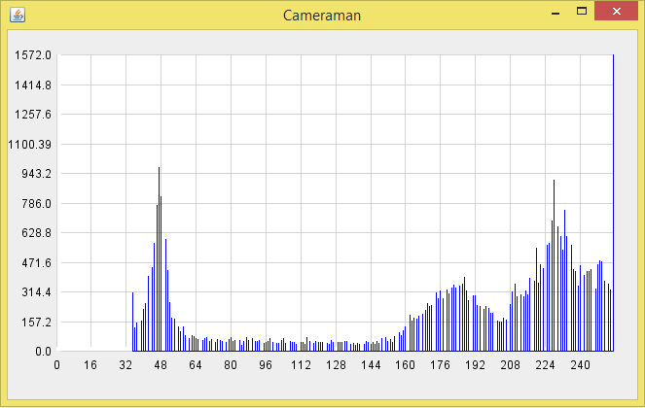
รูป Input
Histogram input
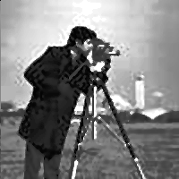
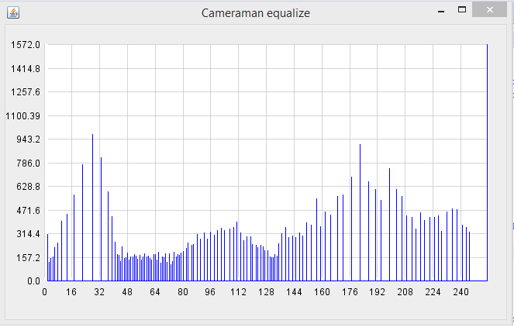
รูป Output
Histogram output

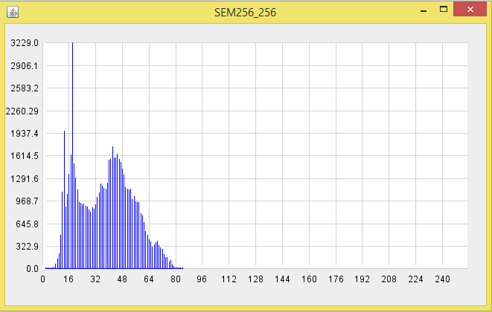
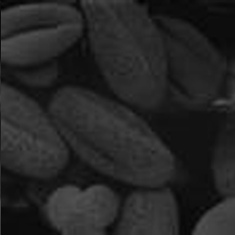
รูป Input
Histogram input

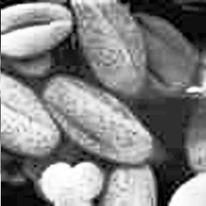
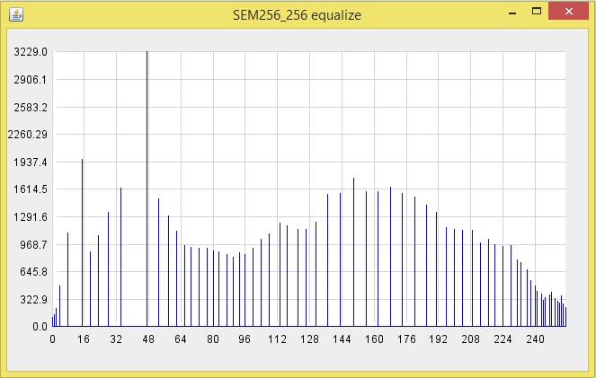
รูป Output
Histogram output
จากการทำ Histogram Equalization ทำให้รูป output ที่ได้ มีความถี่แต่ละ gray level ใกล้เคียงกันมากขึ้น
ทำให้ รูป Camera man ที่มีสีค่อนข้างสว่าง มืดลง และรูป SEM256_256 ที่มีสีค่อนข้างมืด สว่างขึ้น หลังผ่านการทำ Histogram Equalization
3. Algebraic Operations
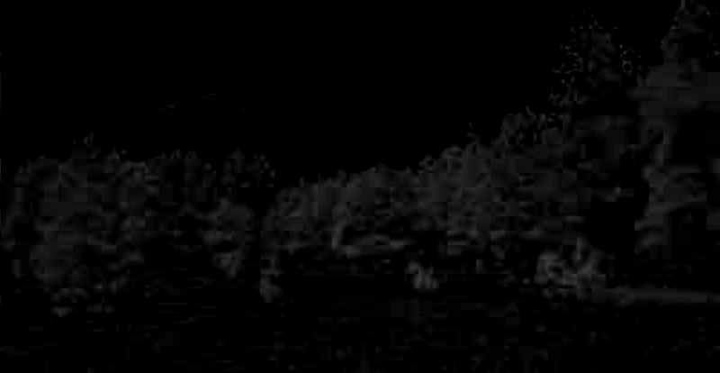
Excess Green
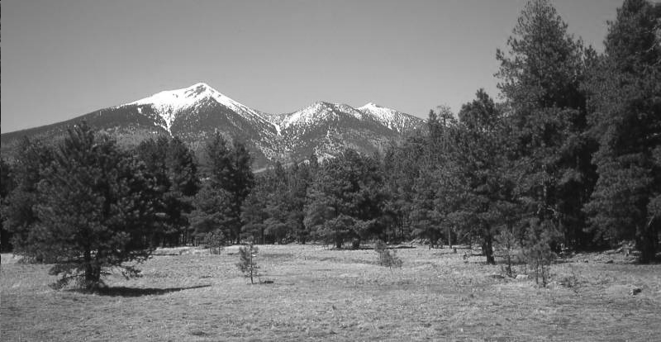
Intensity
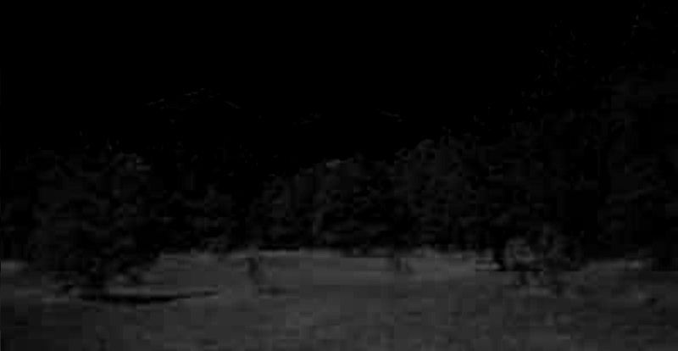
red-blue difference
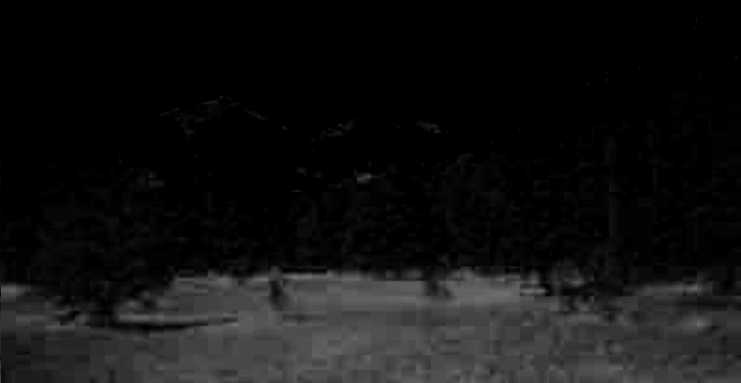
Excess Red (ทำให้ค่าสีแดง เด่นขึ้นมา)

4. Geometric Operations

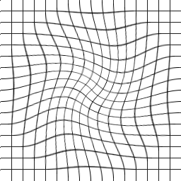
ในการทำ Control grid interpolation เพื่อทำให้รูปที่เบี้ยว กลับมาเป็นรูปปกติ เริ่มจากการหาจุดตัดแต่ละเส้นของรูป grid.pgm และรูป distgrid.pgm โดยรูป grid.pgm หาจุดตัดโดยการทำ Convolute ด้วย kernel รูปบวก ที่มี origin ตรงกลาง รูป output จะได้รูปที่มีค่าตรงจุดตัดมากกว่าจุดอื่นๆ และแปลงรูปที่ได้เป็น binary โดยตัด threshold ที่ 1000 และหาตำแหน่งของจุดนั้นต่อไป ส่วนจุดตัดในรูป distgrid.pgm ได้มาจากเทพต้าร์ที่ใช้มือจิ้มเองครับ เมื่อได้จุดตัดของสองรูปมาแล้ว ก็ใช้ วิธี Gaussian Elimination เพื่อแก้สมการ จากนั้นนำค่าทุก pixel ของรูป output มาแทนในสมการ จะได้ตำแหน่งของรูปเบี้ยว และใช้วิธี Nearest neightbor interpolation เพื่อปัดค่า และนำค่า gray level ที่ตำแหน่งนั้น มาแทนในรูป output

รูป grid รูป distgrid

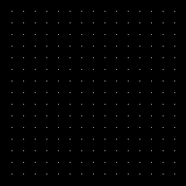
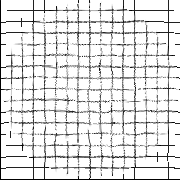
รูป grid หลัง convolute รูป distgrid หลังทำ Control grid interpolation
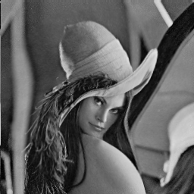
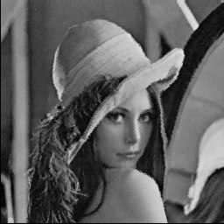
รูป distlenna รูป distlenna หลังทำ Control grid interpolation

Code (โค๊ดทั้งหมดอยู่ที่ https://github.com/porpeeranut/Digital_Image_Processing_Assignment1 )
main_1.java
public class main_1 {
public static void main(String[] args) {
String fileName;
fileName = "D:\\Google Drive\\CMU\\3rd\\semester 2\\261453 Digital Image Processing\\HW2\\scaled_shapes.pgm";
int[][] pic = func.getPGMdata(fileName);
int[] Histogram = func.getHistogramAndPrintGrayLV(pic, 100);
func.showGraph(Histogram, "scaled_shapes");

// get grayLV each obj
int[] grayLVeachObj = new int[6];
int j = 0, threshold = 100;
for (int i = 0; i < Histogram.length; i++) {
if (Histogram[i] > threshold)
grayLVeachObj[j++] = i;
}

// loop each obj
for (int i = 0; i < grayLVeachObj.length; i++) {
String fileNameout = "D:\\Google Drive\\CMU\\3rd\\semester 2\\261453 Digital Image Processing\\HW2\\1scaled_shapes"+i+".pgm";
func.writePGMfile(fileNameout, func.getBW0255_imageFromGrayLVThreshold(pic, grayLVeachObj[i]));
int[][] pic01_lv0 = func.getBW01_imageFromGrayLVThreshold(pic, grayLVeachObj[i]);
double m00 = func.getMomentFromBW01(pic01_lv0, 0, 0);
double m10 = func.getMomentFromBW01(pic01_lv0, 1, 0);
double m01 = func.getMomentFromBW01(pic01_lv0, 0, 1);
double x = m10/m00;
double y = m01/m00;

double n20 = func.getNormalizedMomentFromBW01(pic01_lv0, 2, 0, x, y);
double n02 = func.getNormalizedMomentFromBW01(pic01_lv0, 0, 2, x, y);
double quantity = n20+n02;
System.out.println("x "+x+", y "+y+", quantity "+quantity);
System.out.println();
}
}
}

main_2.java
public class main_2 {
public static void main(String[] args) {
String fileName1, fileName2;
fileName1 = "D:\\Google Drive\\CMU\\3rd\\semester 2\\261453 Digital Image Processing\\HW2\\Cameraman.pgm";
fileName2 = "D:\\Google Drive\\CMU\\3rd\\semester 2\\261453 Digital Image Processing\\HW2\\SEM256_256.pgm";
int[][] pic1 = func.getPGMdata(fileName1);
int[][] pic2 = func.getPGMdata(fileName2);
int[] Histogram1 = func.getHistogram(pic1);
int[] Histogram2 = func.getHistogram(pic2);
func.showGraph(Histogram1, "Cameraman");
func.showGraph(Histogram2, "SEM256_256");

double area = pic1.length*pic1[0].length;
pic1 = func.histogramEqualize(Histogram1, area, pic1);
String fileNameout = "D:\\Google Drive\\CMU\\3rd\\semester 2\\261453 Digital Image Processing\\HW2\\2Cameraman.pgm";
func.writePGMfile(fileNameout, pic1);
Histogram1 = func.getHistogram(pic1);
func.showGraph(Histogram1, "Cameraman equalize");

area = pic2.length*pic2[0].length;
pic2 = func.histogramEqualize(Histogram2, area, pic2);
fileNameout = "D:\\Google Drive\\CMU\\3rd\\semester 2\\261453 Digital Image Processing\\HW2\\2SEM256_256.pgm";
func.writePGMfile(fileNameout, pic2);
Histogram2 = func.getHistogram(pic2);
func.showGraph(Histogram2, "SEM256_256 equalize");
}
}
main_3.java
public class main_3 {
public static void main(String[] args) {
String fileR, fileG, fileB;
fileB = "D:\\Google Drive\\CMU\\3rd\\semester 2\\261453 Digital Image Processing\\HW2\\SanFranPeak_blue.pgm";
fileG = "D:\\Google Drive\\CMU\\3rd\\semester 2\\261453 Digital Image Processing\\HW2\\SanFranPeak_green.pgm";
fileR = "D:\\Google Drive\\CMU\\3rd\\semester 2\\261453 Digital Image Processing\\HW2\\SanFranPeak_red.pgm";
int[][] picB = func.getPGMdata(fileB);
int[][] picR = func.getPGMdata(fileR);
int[][] picG = func.getPGMdata(fileG);
int[] histR = func.getHistogram(picR);
int[] histG = func.getHistogram(picG);
int[] histB = func.getHistogram(picB);
func.showGraph(histB, "SanFranPeak_blue");
func.showGraph(histG, "SanFranPeak_green");
func.showGraph(histR, "SanFranPeak_red");

int[][] picExcessGreen = new int[picB.length][picB[0].length];
int[][] picRedBlueDiff = new int[picB.length][picB[0].length];
int[][] picIntensity = new int[picB.length][picB[0].length];
int[][] picExcessRed = new int[picB.length][picB[0].length];
//---------------------------------------------------------------
for (int row = 0; row < picB.length; row++) {
for (int col = 0; col < picB[0].length; col++) {
int val = 2*picG[row][col] - picR[row][col] - picB[row][col];
if (val < 0)
val = 0;
if (val > 255)
val = 255;
picExcessGreen[row][col] = val;
}
}
//---------------------------------------------------------------
for (int row = 0; row < picB.length; row++) {
for (int col = 0; col < picB[0].length; col++) {
int val = picR[row][col] - picB[row][col];
if (val < 0)
val = 0;
if (val > 255)
val = 255;
picRedBlueDiff[row][col] = val;
}
}
//---------------------------------------------------------------
for (int row = 0; row < picB.length; row++) {
for (int col = 0; col < picB[0].length; col++) {
int val = (picR[row][col] + picB[row][col] + picG[row][col])/3;
if (val < 0)
val = 0;
if (val > 255)
val = 255;
picIntensity[row][col] = val;
}
}
//---------------------------------------------------------------
for (int row = 0; row < picB.length; row++) {
for (int col = 0; col < picB[0].length; col++) {
int val = 2*picR[row][col] - picG[row][col] - picB[row][col];
if (val < 0)
val = 0;
if (val > 255)
val = 255;
picExcessRed[row][col] = val;
}
}
//---------------------------------------------------------------
String fileExcessGreen = "D:\\Google Drive\\CMU\\3rd\\semester 2\\261453 Digital Image Processing\\HW2\\3ExcessGreen.pgm";
String fileRedBlueDiff = "D:\\Google Drive\\CMU\\3rd\\semester 2\\261453 Digital Image Processing\\HW2\\3RedBlueDiff.pgm";
String fileIntensity = "D:\\Google Drive\\CMU\\3rd\\semester 2\\261453 Digital Image Processing\\HW2\\3Intensity.pgm";
String fileExcessRed = "D:\\Google Drive\\CMU\\3rd\\semester 2\\261453 Digital Image Processing\\HW2\\3ExcessRed.pgm";
func.writePGMfile(fileExcessGreen, picExcessGreen);
func.writePGMfile(fileRedBlueDiff, picRedBlueDiff);
func.writePGMfile(fileIntensity, picIntensity);
func.writePGMfile(fileExcessRed, picExcessRed);
}
}

main_4.java
public class main_4 {
public static void main(String[] args) {
String fileGrid, fileDisgrid, fileLena;
fileDisgrid = "D:\\Google Drive\\CMU\\3rd\\semester 2\\261453 Digital Image Processing\\HW2\\distgrid.pgm";
fileLena = "D:\\Google Drive\\CMU\\3rd\\semester 2\\261453 Digital Image Processing\\HW2\\distlenna.pgm";
fileGrid = "D:\\Google Drive\\CMU\\3rd\\semester 2\\261453 Digital Image Processing\\HW2\\grid.pgm";
int[][] picGrid = func.getPGMdata(fileGrid);
int[][] picDisgrid = func.getPGMdata(fileDisgrid);
int[][] picLena = func.getPGMdata(fileLena);
int[][] newPic = new int[picLena.length][picLena[0].length];

// Convolute to find cross point in grid file
int[][] F = new int[picGrid.length][picGrid[0].length];
for (int row = 0; row < picGrid.length; row++) {
for (int col = 0; col < picGrid[0].length; col++) {
F[row][col] = 255 - picGrid[row][col];
}
}
int[][] G = new int[][]{
{ 0, 1, 0 },
{ 1, 1, 1 },
{ 0, 1, 0 }};
int[][] C = new int[picGrid.length][picGrid[0].length];
C = func.convoluteOriginCenter(F, G);

String fileNameout = "D:\\Google Drive\\CMU\\3rd\\semester 2\\261453 Digital Image Processing\\HW2\\4GridConvolute.pgm";
func.writePGMfile(fileNameout, C);

int[][][] gridXY = new int[17][17][2];
int[][][] disgridXY = func.disgridXY;
gridXY = func.findGridXY(C);

newPic = func.controlGrid(gridXY, disgridXY, picDisgrid);
fileNameout = "D:\\Google Drive\\CMU\\3rd\\semester 2\\261453 Digital Image Processing\\HW2\\4disgridAfter.pgm";
func.writePGMfile(fileNameout, newPic);

newPic = func.controlGrid(gridXY, disgridXY, picLena);
fileNameout = "D:\\Google Drive\\CMU\\3rd\\semester 2\\261453 Digital Image Processing\\HW2\\4lenaAfter.pgm";
func.writePGMfile(fileNameout, newPic);
}
}

Func.java
import java.awt.BasicStroke;
import java.awt.Color;
import java.awt.Dimension;
import java.awt.FontMetrics;
import java.awt.Graphics;
import java.awt.Graphics2D;
import java.awt.Point;
import java.awt.RenderingHints;
import java.awt.Stroke;
import java.io.FileInputStream;
import java.io.FileNotFoundException;
import java.io.FileOutputStream;
import java.io.IOException;
import java.util.ArrayList;
import java.util.List;

import javax.swing.JFrame;
import javax.swing.JPanel;

public class func extends JPanel {
private int padding = 25;
private int labelPadding = 25;
//private Color lineColor = new Color(44, 102, 230, 180);
private Color lineColor = Color.BLUE;
private Color pointColor = new Color(100, 100, 100, 180);
private Color gridColor = new Color(200, 200, 200, 200);
private static final Stroke GRAPH_STROKE = new BasicStroke(1f);
private int pointWidth = 4;
private int numberYDivisions = 10;
private List<Double> Values;

public func(List<Double> Values) {
this.Values = Values;
}

@Override
protected void paintComponent(Graphics g) {
super.paintComponent(g);
Graphics2D g2 = (Graphics2D) g;
g2.setRenderingHint(RenderingHints.KEY_ANTIALIASING, RenderingHints.VALUE_ANTIALIAS_ON);

double xScale = ((double) getWidth() - (2 * padding) - labelPadding) / (Values.size() - 1);
double yScale = ((double) getHeight() - 2 * padding - labelPadding) / (getMaxScore() - getMinScore());

List<Point> graphPoints = new ArrayList<>();
for (int i = 0; i < Values.size(); i++) {
int x1 = (int) (i * xScale + padding + labelPadding);
int y1 = (int) ((getMaxScore() - Values.get(i)) * yScale + padding);
if (y1 != (int) ((getMaxScore() - 0) * yScale + padding)) {
graphPoints.add(new Point(x1, (int) ((getMaxScore() - 0) * yScale + padding)));
graphPoints.add(new Point(x1, y1));
graphPoints.add(new Point(x1, (int) ((getMaxScore() - 0) * yScale + padding)));
}
}

// draw white background
g2.setColor(Color.WHITE);
g2.fillRect(padding + labelPadding, padding, getWidth() - (2 * padding) - labelPadding, getHeight() - 2 * padding - labelPadding);
g2.setColor(Color.BLACK);

// create hatch marks and grid lines for y axis.
for (int i = 0; i < numberYDivisions + 1; i++) {
int x0 = padding + labelPadding;
int x1 = pointWidth + padding + labelPadding;
int y0 = getHeight() - ((i * (getHeight() - padding * 2 - labelPadding)) / numberYDivisions + padding + labelPadding);
int y1 = y0;
if (Values.size() > 0) {
g2.setColor(gridColor);
g2.drawLine(padding + labelPadding + 1 + pointWidth, y0, getWidth() - padding, y1);
g2.setColor(Color.BLACK);
String yLabel = ((int) ((getMinScore() + (getMaxScore() - getMinScore()) * ((i * 1.0) / numberYDivisions)) * 100)) / 100.0 + "";
FontMetrics metrics = g2.getFontMetrics();
int labelWidth = metrics.stringWidth(yLabel);
g2.drawString(yLabel, x0 - labelWidth - 5, y0 + (metrics.getHeight() / 2) - 3);
}
//g2.drawLine(x0, y0, x1, y1);
}

// and for x axis
for (int i = 0; i < Values.size(); i++) {
if (Values.size() > 1) {
int x0 = i * (getWidth() - padding * 2 - labelPadding) / (Values.size() - 1) + padding + labelPadding;
int x1 = x0;
int y0 = getHeight() - padding - labelPadding;
int y1 = y0 - pointWidth;
if ((i % ((int) ((Values.size() / 17.0)) + 1)) == 0) {
g2.setColor(gridColor);
g2.drawLine(x0, getHeight() - padding - labelPadding - 1 - pointWidth, x1, padding);
g2.setColor(Color.BLACK);
String xLabel = i + "";
FontMetrics metrics = g2.getFontMetrics();
int labelWidth = metrics.stringWidth(xLabel);
g2.drawString(xLabel, x0 - labelWidth / 2, y0 + metrics.getHeight() + 3);
}
//g2.drawLine(x0, y0, x1, y1);
}
}

// create x and y axes
/*g2.drawLine(padding + labelPadding, getHeight() - padding - labelPadding, padding + labelPadding, padding);
g2.drawLine(padding + labelPadding, getHeight() - padding - labelPadding, getWidth() - padding, getHeight() - padding - labelPadding);*/

Stroke oldStroke = g2.getStroke();
g2.setColor(lineColor);
g2.setStroke(GRAPH_STROKE);
for (int i = 0; i < graphPoints.size() - 1; i++) {
int x1 = graphPoints.get(i).x;
int y1 = graphPoints.get(i).y;
int x2 = graphPoints.get(i + 1).x;
int y2 = graphPoints.get(i + 1).y;
g2.drawLine(x1, y1, x2, y2);
}

// draw point
/*g2.setStroke(oldStroke);
g2.setColor(pointColor);
for (int i = 0; i < graphPoints.size(); i++) {
int x = graphPoints.get(i).x - pointWidth / 2;
int y = graphPoints.get(i).y - pointWidth / 2;
int ovalW = pointWidth;
int ovalH = pointWidth;
g2.fillOval(x, y, ovalW, ovalH);
}*/
}

// @Override
// public Dimension getPreferredSize() {
// return new Dimension(width, heigth);
// }
public double getMinScore() {
double minScore = Double.MAX_VALUE;
for (Double score : Values) {
minScore = Math.min(minScore, score);
}
return minScore;
}

public double getMaxScore() {
double maxScore = Double.MIN_VALUE;
for (Double score : Values) {
maxScore = Math.max(maxScore, score);
}
return maxScore;
}

public void setValues(List<Double> Values) {
this.Values = Values;
invalidate();
this.repaint();
}

public List<Double> getValues() {
return Values;
}

public static void showGraph(int[] histrogram, String head) {
List<Double> yData = new ArrayList<>();
for (int i = 0; i < histrogram.length; i++) {
yData.add((double) histrogram[i]);
}
func mainPanel = new func(yData);
mainPanel.setPreferredSize(new Dimension(800, 600));
JFrame frame = new JFrame(head);
frame.setDefaultCloseOperation(JFrame.EXIT_ON_CLOSE);
frame.getContentPane().add(mainPanel);
frame.pack();
frame.setLocationRelativeTo(null);
frame.setVisible(true);
}

public func() {}

public static int[] getHistogram(int[][] picData) {
int[] Histogram = new int[256];
for (int row = 0; row < picData.length; row++) {
for (int col = 0; col < picData[0].length; col++) {
Histogram[picData[row][col]]++;
}
}
return Histogram;
}

public static int[][] getBW01_imageFromGrayLVThreshold(int[][] picIn, int threshold) {
int[][] picOut = new int[picIn.length][picIn[0].length];
for (int row = 0; row < picIn.length; row++) {
for (int col = 0; col < picIn[0].length; col++) {
if (picIn[row][col] == threshold)
picOut[row][col] = 1;
else
picOut[row][col] = 0;
}
}
return picOut;
}

public static int[][] getBW0255_imageFromGrayLVThreshold(int[][] picIn, int threshold) {
int[][] picOut = new int[picIn.length][picIn[0].length];
for (int row = 0; row < picIn.length; row++) {
for (int col = 0; col < picIn[0].length; col++) {
if (picIn[row][col] == threshold)
picOut[row][col] = 255;
else
picOut[row][col] = 0;
}
}
return picOut;
}

public static int getMomentFromBW01(int[][] pic, int p, int q) {
int m = 0;
for (int y = 0; y < pic.length; y++) {
for (int x = 0; x < pic[0].length; x++) {
m += Math.pow(x, p)*Math.pow(y, q)*pic[y][x];
}
}
return m;
}

public static double getCentralMomentFromBW01(int[][] pic, int p, int q, double x_, double y_) {
double u = 0;
for (int y = 0; y < pic.length; y++) {
for (int x = 0; x < pic[0].length; x++) {
u += Math.pow(x-x_, p)*Math.pow(y-y_, q)*pic[y][x];
}
}
return u;
}

public static double getNormalizedMomentFromBW01(int[][] pic, int p, int q, double x_, double y_) {
double Upq = getCentralMomentFromBW01(pic, p, q, x_, y_);
double U00 = getCentralMomentFromBW01(pic, 0, 0, x_, y_);
System.out.println("U"+p+q+" "+Upq+", U00 "+U00);
double n = Upq/Math.pow(U00, ((p+q)/2)+1);
return n;
}

public static int[] getHistogramAndPrintGrayLV(int[][] picData, int threshold) {
int[] Histogram = new int[256];
for (int row = 0; row < picData.length; row++) {
for (int col = 0; col < picData[0].length; col++) {
Histogram[picData[row][col]]++;
}
}
for (int i = 0; i < Histogram.length; i++) {
if (Histogram[i] > threshold)
System.out.println("level "+i+", val "+Histogram[i]);
}
return Histogram;
}

public static int[][] getPGMdata(String fileName) {
FileInputStream fin;
int[][] picData = null;
try {
fin = new FileInputStream(fileName);
int len;
byte data[] = new byte[fin.available()];
boolean isComment = false;
boolean isWid = true;
boolean isHigh = false;
int line = 1;

int width, height;
String strWid = "", strHigh = "", strMaxGval = "";
len = fin.read(data);
for (int j = 0; j < len; j++) {
// skip comment
if (data[j] == '#') {
isComment = true;
continue;
}
if (isComment) {
if (data[j] == 0x0a) {
isComment = false;
line++;
}
continue;
}

if (line == 1) {
if (data[j] == 0x0a) {
line++;
continue;
}
if (data[j] == 'P' && data[j+1] == '5') {
j += 2;
continue;
} else {
System.out.printf("not pgm file");
return null;
}
} else if (line == 2) {
if (data[j] == ' ') {
isWid = false;
isHigh = true;
continue;
}
if (data[j] == 0x0d)
continue;
if (data[j] == 0x0a) {
line++;
continue;
}
if (isWid)
strWid += "" + (char)data[j];
if (isHigh)
strHigh += "" + (char)data[j];
} else if (line == 3) {
if (data[j] == 0x0d)
continue;
if (data[j] == 0x0a) {
line++;
continue;
}
strMaxGval += "" + (char)data[j];
} else {
width = Integer.valueOf(strWid);
height = Integer.valueOf(strHigh);
picData = new int[height][width];
for (int row = 0; row < height; row++) {
for (int col = 0; col < width; col++) {
picData[row][col] = data[j] & 0xFF;
j++;
}
}
break;
}
}

System.out.print("wid "+strWid);
System.out.print(", high "+strHigh);
System.out.println(", max "+strMaxGval);
return picData;
} catch (FileNotFoundException e) {
e.printStackTrace();
} catch (IOException e) {
e.printStackTrace();
}
return null;
}

public static void writePGMfile(String fileNamepath, int[][] pic) {
FileOutputStream fos;
try {
fos = new FileOutputStream(fileNamepath);
String head = "P5\r\n";
head += pic[0].length + " " + pic.length + "\r\n";
head += "255\r\n";
fos.write(head.getBytes());
for (int row = 0; row < pic.length; row++) {
for (int col = 0; col < pic[0].length; col++) {
fos.write((byte)pic[row][col]);
}
}
fos.close();
} catch (FileNotFoundException e) {
e.printStackTrace();
} catch (IOException e) {
e.printStackTrace();
}
}

public static int[][] histogramEqualize(int[] Histo, double area, int[][] pic) {
int maxGrayLV = 255;
double[] HistDevideArea = new double[Histo.length];
double[] PA = new double[Histo.length];
int[] fDa = new int[Histo.length];

// find Ha(Da)/Area
for (int i = 0;i < Histo.length;i++) {
HistDevideArea[i] = Histo[i]/area;
}

// find P(A(x,y))
PA[0] = HistDevideArea[0];
for (int i = 1;i < Histo.length;i++) {
PA[i] = HistDevideArea[i] + PA[i-1];
}

// find f(Da)
for (int i = 0;i < Histo.length;i++) {
fDa[i] = (int) Math.round(PA[i] * maxGrayLV);
}

// convert value in pic
for (int row = 0; row < pic.length; row++) {
for (int col = 0; col < pic[0].length; col++) {
pic[row][col] = fDa[pic[row][col]];
}
}
return pic;
}

public static int[][] controlGrid(int[][][] gridXY, int[][][] disgridXY2, int[][] pic) {
int x1, x2, x3, x4;
int y1, y2, y3, y4;
double[][] xy = new double[4][4];
double[] x_ = new double[4];
double[] y_ = new double[4];
double[] Wx = new double[4];
double[] Wy = new double[4];
double[][] V = new double[xy.length][];
int[][] newPic = new int[pic.length][pic[0].length];
for (int row = 0; row < gridXY.length-1; row++) {
for (int col = 0; col < gridXY[0].length-1; col++) {
x1 = gridXY[row][col][0];
y1 = gridXY[row][col][1];
x2 = gridXY[row][col+1][0];
y2 = gridXY[row][col+1][1];
x3 = gridXY[row+1][col][0];
y3 = gridXY[row+1][col][1];
x4 = gridXY[row+1][col+1][0];
y4 = gridXY[row+1][col+1][1];

// x'1
xy[0][0] = x1;
xy[0][1] = y1;
xy[0][2] = x1*y1;
xy[0][3] = 1;

// x'2
xy[1][0] = x2;
xy[1][1] = y2;
xy[1][2] = x2*y2;
xy[1][3] = 1;

// x'3
xy[2][0] = x3;
xy[2][1] = y3;
xy[2][2] = x3*y3;
xy[2][3] = 1;

// x'4
xy[3][0] = x4;
xy[3][1] = y4;
xy[3][2] = x4*y4;
xy[3][3] = 1;

x_[0] = disgridXY[row][col][0];
x_[1] = disgridXY[row][col+1][0];
x_[2] = disgridXY[row+1][col][0];
x_[3] = disgridXY[row+1][col+1][0];

y_[0] = disgridXY[row][col][1];
y_[1] = disgridXY[row][col+1][1];
y_[2] = disgridXY[row+1][col][1];
y_[3] = disgridXY[row+1][col+1][1];

for(int i = 0; i < xy.length; i++)
V[i] = xy[i].clone();
Wx = gaussianElimination(V, x_.clone());

for(int i = 0; i < xy.length; i++)
V[i] = xy[i].clone();
Wy = gaussianElimination(V, y_.clone());

for (int y = y1; y < y3; y++) {
for (int x = x1; x < x2; x++) {
int xp = (int) Math.round(Wx[0]*x + Wx[1]*y + Wx[2]*x*y + Wx[3]);
int yp = (int) Math.round(Wy[0]*x + Wy[1]*y + Wy[2]*x*y + Wy[3]);
if (xp > 255)
xp = 255;
if (yp > 255)
yp = 255;

newPic[y][x] = pic[yp][xp];
}
}
}
}
return newPic;
}

public static int[][] convoluteOriginCenter(int[][] F, int[][] G) {
// flip G left-right
int[][] tmp = new int[G.length][G[0].length];
for (int row = 0; row < G.length; row++) {
for (int col = 0; col < G[0].length; col++) {
tmp[row][col] = G[row][(G[0].length-1) - col];
}
}
// flip G up-down
for (int row = 0; row < G.length; row++) {
for (int col = 0; col < G[0].length; col++) {
G[row][col] = tmp[(G.length-1) - row][col];
}
}

// padding
int topPadSize = (int) Math.floor(G.length/2);
int leftPadSize = (int) Math.floor(G[0].length/2);
int[][] C = new int[(int) (F.length + topPadSize*2)][(int) (F[0].length + leftPadSize*2)];
for (int row = topPadSize; row < C.length - topPadSize; row++) {
for (int col = leftPadSize; col < C[0].length - leftPadSize; col++) {
C[row][col] = F[row - topPadSize][col - leftPadSize];
}
}

// convolute
int max = 0;
for (int Cy = topPadSize;Cy < C.length - topPadSize; Cy++) {
for (int Cx = leftPadSize;Cx < C[0].length - leftPadSize; Cx++) {
int val = 0;
for (int row = 0; row < G.length; row++) {
for (int col = 0; col < G[0].length; col++)
val += G[row][col] * C[(Cy-topPadSize)+row][(Cx-leftPadSize)+col];
}
/*if (max < val)
max = val;*/
if (val > 1000)
val = 255;
else
val = 0;
F[Cy-topPadSize][Cx-leftPadSize] = val;
}
}
//System.out.println("max "+max);
return F;
}

public static int[][][] findGridXY(int[][] image0255) {
int[][][] gridXY = new int[17][17][2];
int x;
int y = 1;
for (int i = 0; i < 17; i++) {
gridXY[0][i][0] = i*16;
gridXY[0][i][1] = 0;
if (i != 0)
gridXY[0][i][0]--;
}
for (int row = 0; row < image0255.length; row++) {
gridXY[y][0][0] = 0;
gridXY[y][0][1] = y*16;
x = 1;
for (int col = 0; col < image0255[0].length; col++) {
if (image0255[row][col] == 255) {
gridXY[y][x][0] = col;
gridXY[y][x++][1] = row;
if (x == 16) {
x = 1;
gridXY[y][16][0] = 255;
gridXY[y][16][1] = y*16;
y++;
}
}
}
}
for (int i = 0; i < 17; i++) {
gridXY[16][i][0] = i*16;
gridXY[16][i][1] = 255;
if (i != 0)
gridXY[16][i][0]--;
}
return gridXY;
}

private static final double EPSILON = 1e-10;

// Gaussian elimination with partial pivoting
public static double[] gaussianElimination(double[][] A, double[] b) {
int N = b.length;

for (int p = 0; p < N; p++) {

// find pivot row and swap
int max = p;
for (int i = p + 1; i < N; i++) {
if (Math.abs(A[i][p]) > Math.abs(A[max][p])) {
max = i;
}
}
double[] temp = A[p]; A[p] = A[max]; A[max] = temp;
double t = b[p]; b[p] = b[max]; b[max] = t;

// singular or nearly singular
if (Math.abs(A[p][p]) <= EPSILON) {
throw new RuntimeException("Matrix is singular or nearly singular");
}

// pivot within A and b
for (int i = p + 1; i < N; i++) {
double alpha = A[i][p] / A[p][p];
b[i] -= alpha * b[p];
for (int j = p; j < N; j++) {
A[i][j] -= alpha * A[p][j];
}
}
}

// back substitution
double[] x = new double[N];
for (int i = N - 1; i >= 0; i--) {
double sum = 0.0;
for (int j = i + 1; j < N; j++) {
sum += A[i][j] * x[j];
}
x[i] = (b[i] - sum) / A[i][i];
}
return x;
}

public static int[][][] disgridXY = new int[][][] {
// x1, y1, x2, y2, x3, y3, x4, y4
{{0, 0},{16, 0},{32, 0},{48, 0},{64, 0},{80, 0},{96, 0},{112, 0},{128, 0},{144, 0},{160, 0},{176, 0},{192, 0},{208, 0},{224, 0},{240, 0},{256, 0}},
{{0, 16},{16, 16},{32, 16},{48, 16},{64, 16},{79, 16},{97, 17},{114, 19},{130, 18},{146, 19},{160, 18},{176, 17},{192, 16},{208, 16},{224, 16},{240, 16},{256, 16}},
{{0, 32},{16, 32},{33, 32},{48, 32},{67, 31},{85, 35},{103, 37},{121, 40},{136, 42},{150, 43},{162, 41},{177, 37},{192, 35},{208, 32},{224, 32},{240, 31},{256, 32}},
{{0, 48},{16, 48},{32, 48},{51, 49},{72, 49},{94, 53},{112, 56},{128, 60},{141, 63},{154, 65},{166, 65},{178, 62},{192, 57},{206, 52},{224, 48},{240, 48},{256, 48}},
{{0, 64},{16, 64},{34, 64},{56, 63},{80, 66},{99, 68},{116, 72},{132, 76},{144, 80},{156, 84},{167, 85},{177, 83},{190, 80},{204, 74},{222, 66},{240, 64},{256, 64}},
{{0, 80},{16, 80},{37, 78},{63, 78},{84, 78},{103, 81},{119, 85},{132, 89},{144, 94},{154, 100},{165, 103},{176, 102},{188, 100},{203, 94},{221, 85},{240, 80},{256, 80}},
{{0, 96},{16, 96},{41, 93},{65, 91},{86, 90},{102, 90},{118, 96},{130, 102},{141, 108},{152, 116},{161, 117},{172, 119},{184, 116},{200, 112},{217, 105},{237, 97},{256, 96}},
{{0, 112},{18, 110},{42, 106},{65, 103},{84, 101},{100, 102},{114, 105},{127, 112},{136, 119},{145, 126},{154, 130},{167, 132},{180, 132},{196, 128},{215, 122},{237, 115},{256, 112}},
{{0, 128},{19, 126},{41, 120},{64, 113},{81, 112},{96, 112},{109, 115},{121, 120},{129, 128},{137, 135},{148, 141},{161, 143},{174, 144},{193, 142},{213, 137},{236, 131},{256, 128}},
{{0, 144},{18, 141},{40, 135},{60, 129},{76, 125},{90, 124},{101, 125},{113, 129},{121, 136},{131, 144},{142, 150},{156, 154},{172, 154},{190, 154},{212, 149},{236, 145},{256, 144}},
{{0, 160},{17, 160},{38, 151},{57, 144},{72, 140},{85, 138},{96, 138},{106, 141},{115, 148},{126, 153},{138, 161},{153, 165},{169, 167},{190, 167},{214, 163},{238, 161},{256, 160}},
{{0, 176},{16, 177},{34, 170},{53, 162},{66, 156},{81, 153},{92, 153},{102, 156},{112, 158},{124, 165},{137, 171},{153, 174},{171, 178},{192, 178},{217, 177},{240, 176},{256, 176}},
{{0, 192},{17, 192},{33, 191},{51, 182},{66, 175},{78, 170},{90, 169},{101, 172},{113, 176},{124, 181},{139, 184},{155, 188},{174, 189},{198, 193},{221, 192},{240, 192},{256, 192}},
{{0, 208},{16, 208},{31, 208},{49, 204},{64, 197},{80, 193},{89, 190},{101, 190},{113, 191},{128, 195},{144, 198},{161, 203},{182, 205},{204, 206},{224, 208},{240, 208},{256, 208}},
{{0, 224, 0},{16, 224},{32, 224},{48, 223},{63, 221},{80, 217},{92, 213},{106, 212},{119, 212},{133, 215},{150, 217},{168, 220},{189, 222},{208, 224},{223, 224},{241, 224},{256, 224}},
{{0, 240},{16, 240},{32, 240},{48, 240},{64, 240},{80, 239},{95, 238},{110, 237},{125, 236},{142, 237},{158, 238},{175, 239},{192, 240},{208, 240},{224, 240},{240, 240},{256, 240}},
{{0, 256},{16, 256},{32, 256},{48, 256},{64, 256},{80, 256},{96, 256},{112, 256},{128, 256},{144, 256},{160, 256},{176, 256},{192, 256},{208, 256},{224, 256},{240, 256},{256, 256}}};
}

